**UNIT 2:** *Systems Planning*

IT303: SYSTEMS ANALYSIS AND DESIGN **99**



# LESSON 4:

### ANALYZING THE BUSINESS CASE

OBJECTIVES:

At the end of this lesson, students should be able to:

* define and understand the importance of business case;
* identify and apply the quality approach to composing business case ;
* cite and understand the key elements during a business case composition; and
* create their own business case analysis for an data system project.

Duration: 4 Hours

**UNIT 2:** *Systems Planning*

**Thoughts to Ponder**

*“Going into business without a business plan is like going on a mountain trek without a map or GPS support – you'll eventually get lost and starve!"*

***―*** *Kevin J. Donaldson*

Project Business Case

Before pursuing a project, the potential benefits have to be analyzed during a project business case. This document is additionally the idea for stakeholder decisions and, the selection of project options. The Project Management Institute defines the business case as a 'documented economic feasibility study' that outlines the business needs, the present situation, economic analysis, and proposals. Usually, the structure of business case documents usually tailoring to the wants and expectations of the stakeholders and, therefore, the organization. to gauge the economic effects of a project and make different project options comparable, project managers leverage the tools and techniques of the analysis. (PMBOK Guide Sixth Edition, 2017)

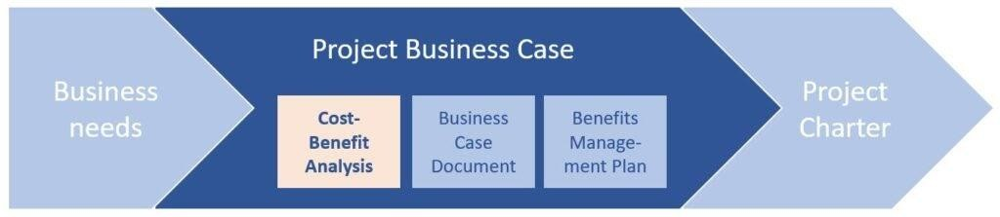

**Figure 2.17 Cost-Benefit Analysis as Part of the Project Business Case.**

Source: Sebastian. (2020, August 09). Cost-Benefit Analysis for Business Cases (Definition, Steps, Example). Retrieved August 31, 2020, from https://project-management.info/cost-benefit-analysis-business-cases/

A business case is often accompanying by a benefits management plan (which is also suggested by the PMBOK). This document points out how the project will make sure that the expected benefits will eventually materialize actually. Both the business case and, therefore, the benefits management plans are the inspiration and input documents of the project charter, which is that the formal documented authorization and mandate for initiating a project. (Sebastian, 2020)

#### Why Use Business Case Analysis?

Business case development may be a step that companies often use for project selection. It contains information about the proposed project, in such a way that the management will be guided in their corporate strategy and competitive advantage towards other businesses. This business case can only be developed to collect pertinent details or information from the management itself based on the evaluation of their existing business processes.

You can also convert the business case to action steps and significant milestones to develop an idea that will guide your venture through the whole project life cycle, including the project outcome. The business case may be a key input to the project management plan and is typically owned and created by the project sponsor. Following project close or completion, a post-project evaluation (PPE) will usually be held- usually some months after project completion – to live the project's benefits against those began in the business case. (Sebastian, 2020)

#### Business Case Composition

Most organizations will have a standard approach to composing a business case. However, key elements usually include:

Executive Summary

Describe the vital points from the business case, including historical background, nature of business, services offered, operational and technical system audit if applicable, competitive advantage, and other pertinent information. This section of the business case is a concise overview of your project's definition and goals. Use this section to clarify the matter and the way you will solve it briefly.

Reasons

Describe the explanations for doing the project, just like the business problems you will be trying to resolve. It will even be useful to explain how the project helps to realize corporate objectives or strategies.

Business Options

Describe the numerous options which are considered and recommend an alternate. One option should be the 'Do nothing' option. This feature does not end during a project. Other options could be 'Do the minimum we can, 'Do something else' etc. The difference between these options is the benefits that the investment will buy. Plan to provide enough information to the approvers of the business case to judge which option gives the only value for money.

Expected Benefits

Describe the benefits of the recommended option in measurable terms. They need to be both qualitative and quantitative.

Expected Downside

Describe any dis-benefits. These are the actual negative consequences of the project. If possible, quantify the dis-benefits and include them within the investment appraisal.

Timescale

Describe the project timescale and the timescale over which the benefits will be realized.

Cost and Benefit Analysis

* + **Costs** - This includes the breakdown of the total sum of your One Time Cost Worksheet, which provides for Development Cost, User Training, and Additional Software/Hardware expenses. Recurring costs on the succeeding year of the implementation of the project should also be calculated.
  + **Benefit -**This includes a breakdown of all tangible benefits of the proposed system, which includes costs such as annual supplies cost of all consumed in the proposed system(pen, ballpen, folder, paper, ink, and the like.) and labor cost of all involved in the proposed system (employees salary).
  + **Break-Even Analysis Table and Break-Even Analysis Chart-** This includes the calculation and graphical representation of break-even point or payback period based on your NPV calculations of Benefits and Cost for a certain period.

Major Risks

Describe the most project risks, their impact which may likely to occur, and any proposed responses.

Recommendations

Give a strong recommendation. Explain why the project you've chosen must be pursuing and why you think this is the best solution. (Buehring, 2020)

#### Business Case Template

**Note:** The example case below was based on a fictitious company. The following paragraphs presented are only for Business Case Template for further understanding of its composition and structure.

**Project Name:** Web Lane Cafe Information Management System

**Project Manager:** Kendra Santos

**Date of Project Approval:** December 1, 2020

Executive Summary

Web Lane Café is a modern chain of cybercafés offering high end and state of the art facilities. Web Lane Café is more of the technologically advanced cybercafés situated at the heart of the city.

At these cafes, you can do the following: Connect to the Web while drinking your favorite specialty coffee or tea and eating a snack; chat with or send email to coworkers, friends, and family; use Internet Explorer, Google Chrome, or AOL to browse the Web; and play online games or read an online book. If customers have questions while using the computer, the cashier also serves as an IT Assistant to provide assistance to its customer. Each café also offers training courses for beginning computer users at a minimal cost.

Nature of Business

How the company provides services to their customer

Through high-speed T1 lines, customers have fast Internet access. Monitors are 19 inches. Cafe has a minimum of 15 computers, along with a color printer, a laser printer, a digital camera, and a scanner. All computers have popular productivity software such as the latest operating system and in-demand software applications. For each beverage or snack purchased, customers receive 30 minutes of free computer use – including Web access. If they would like additional computer time, the fee is PHP50.00 per hour.

Since Web Lane Café started operations in 2005, the business has been thriving. The cafe serves hundreds of customers around the city. The Web site has hundreds of hits a day. John Simmons, chief information officer (CIO) for Web Lane Café, offers one suggestion for its financial success.

"We do not let potential customers of computer vendors pay for the computers and equipment in our cafes. Instead, we allow computer vendors to use our café as a storefront for their products. It provides customers with the opportunity to try out the hardware and software before making a purchase. When customers are ready to purchase computers, we direct them to the vendor's electronic storefront for discount pricing".

To showcase their hardware and software in the cafes, computer vendors request information from John Simmons, chief information officer. The number of these requests is rising quickly. The cost of copying and mailing this material is becoming excessive. For this reason, John would like this vendor information made available on the Web. Vendors could download information sheets, press releases, photographs, and other information from the Web site. Placing this information on the Web would save John and her staff a great deal of time and money.

One of the reasons for the financial success at the Web Lane Café is they do not pay for their computers and equipment in the cafes. Instead, they allow computer vendors to use the café as a storefront for their products. This strategy provides their customers with the opportunity to try the hardware and software before making a purchase. When customers wish to purchase computers, the café's staff directs them to the vendor's online storefront for discount pricing.

To showcase their hardware and software in the cafes, computer vendors request information from the cafe in-charge on that day. The number of these requests is rising quickly. The cost of copying and mailing this material is becoming excessive.

System audit of hardware and software

Brief history of the company

State the competitive advantage of the company towards other competitors

Introduce how the problem of the company arises.

Restatement of the competitive strategy of the company and how their problem arises.

Detailed identification of the problem & background of the existing system

Reasons

The following problems are identified with the current information system at the Web Lane Café:

* + The time employees spend copying and duplicating vendor material is rising quickly, raising the need for extension of their duty and working schedule.
  + Potential vendors do not receive the material as quickly as in the past, which possibly could cause poor relations
  + Resources are wasted, including employee time, equipment usage, and supplies.

Business Options

* + Do nothing and stick on with their usual business practices.
  + Adopt the proposed system and take the risk of investing PHP 178,500.00 to a computerized information system that might give your company a more competitive advantage towards another existing cafe nearby.

Expected Benefits

The following benefits are feasible if the Web site at the Web Lane Café were modified:

* + Potential vendors would be more satisfied, leading to possible long-term relations
  + Supplies expenses would be reduced by more than 45%.`
  + Due to automation procedures, there is a 9% labor cost reduction in the employee's salary due to minimal needs or human labor.
  + Through more efficient use of employees' time, the company could also realize an additional reduction of 15% for the overtime pay of the employee due to the extension of their duty and working schedule.

.Expected Downside

* + Some employees will be terminated due to minimal human intervention because of the computerization process.
  + Lower morale among the employees because overtime payment will be reduced.

Timescale

Initial analysis shows that the system will take approximately 3 to 4 months to implement. (Here you can include your PERT Chart or GANTT Chart)

Cost and Benefit Analysis

* + **Costs**

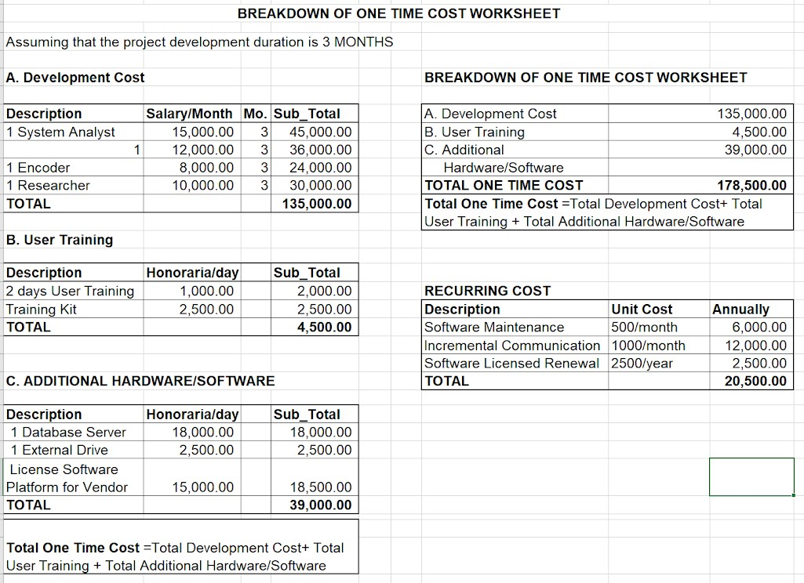

This table taken from Figure 2.8 Breakdown of One Time Cost Worksheet in Lesson 3 shows that there is a total of PHP 178,500.00 for the Total One Time Cost Worksheet, which will serve as the initial investment for this project and the recurring cost of PHP 20,500.00 that will be additional expenses on the cafe for the implementation of the said project.

* + Benefit

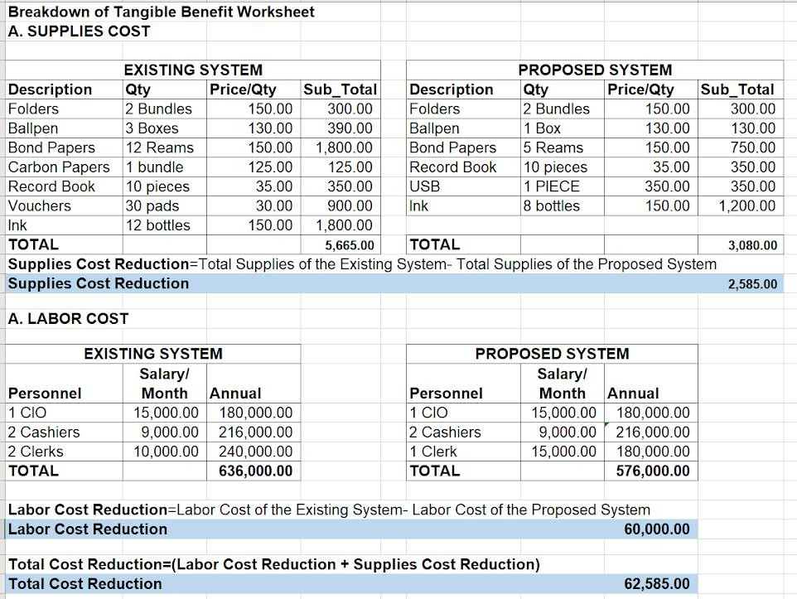

This table taken from Figure 2.9 Breakdown of Tangible Benefit Worksheet in Lesson 3 shows a PHP 2,585.00 annual supplies cost reduction and PHP 60,000.00 labor cost reduction in employee's salaries due to a decrease in the number of employees compared to the labor cost allotment for the existing system.

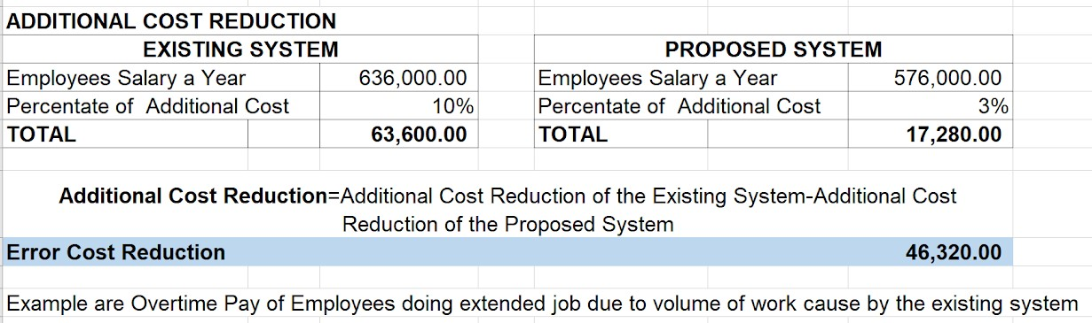

This table taken from Figure 2.10 Additional Cost Reduction Based on Employees Salary in Lesson 3 shows that there is a PHP46, 320.00 cost reduction in the employee's salary compared to the existing labor cost allotment for overtime pay of the employees working in extended duties due to the volume of work in the cafe.

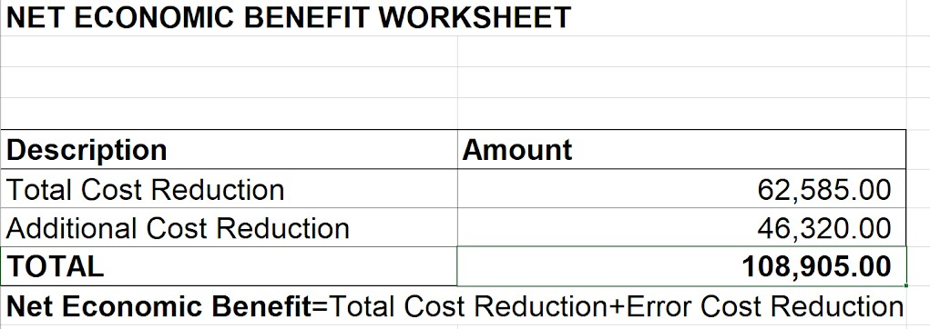

This table is taken from Figure 2.11 Computation of Net Economic Benefit Worksheet in Lesson 3 only shows a total of PHP 108, 905.00 Net Economic Benefit annually if Web Lane Cafe will implement the project.

* + Break-Even Analysis Table and Chart

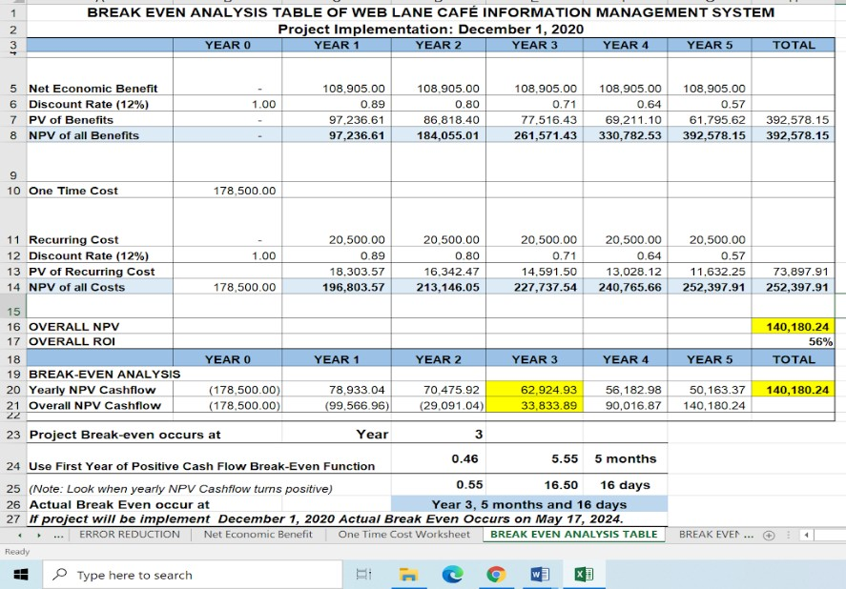

This table taken from Figure 2.15 Example of Break-Even Analysis Table of Web Lane Cafe Information Management System in Lesson 3 shows the detailed computation of the NPV of both Cost and Benefits to come up with the calculation of the ROI and payback period or break-even point as stated in the table above.

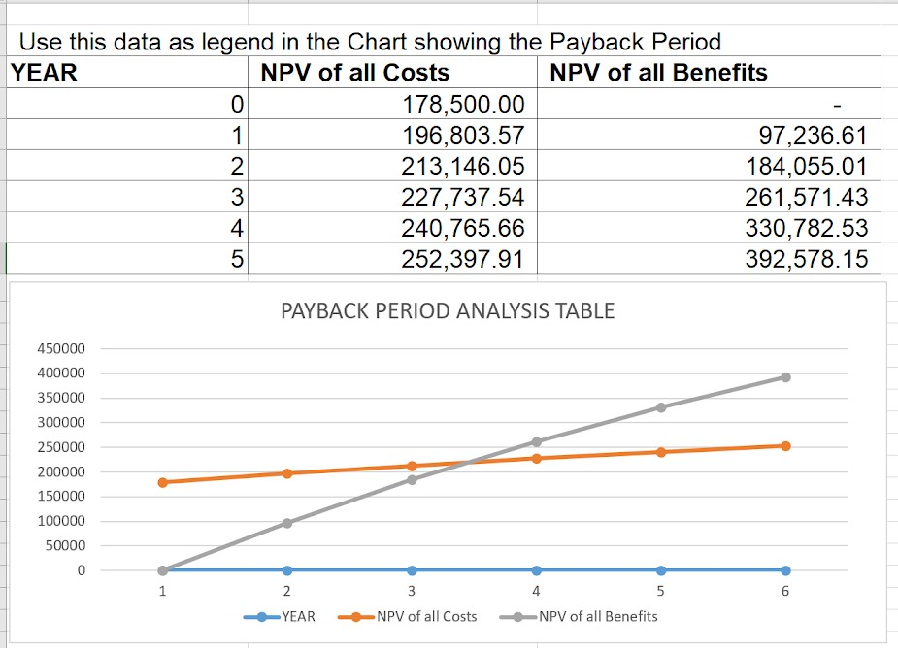

They are taken from Figure 2.16 Example Payback Period Analysis Chart based on Break-Even Analysis Table result of Web Lane Cafe Information Management System. These two tables show that the actual break-even point occurs on Year 3, 5 months, and 16 days. Thus if the project will be implemented on December 1, 2020, it will give an estimated payback period on May 17, 2024.

Major Risks

The project team that will handle the initial data gathering procedure might have lack of experience in specifying requirements on system projects. It could lead to the wrong system software deliverables. It is likely to turn down the benefits projected from the project

Recommendations

Having an ROI of 56% for an initial investment of PHP 178,500.00 and a payback period of 3 Years, 5 months, and 16 days and after careful evaluation and consideration of this proposed information system, I, therefore, conclude that this project is feasible to be implemented at Web Lane Café.